**Git Handson Exercise – 2**

**CODE:**

**debug.log file: -**

Some log data

**logs/error.txt file: -**

Error details

**gitignore file: -**

*.log

logs/

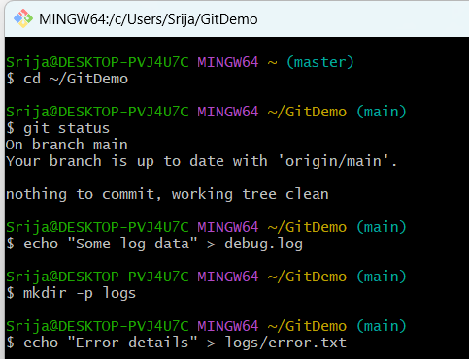

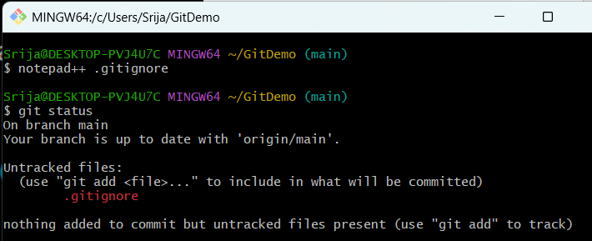

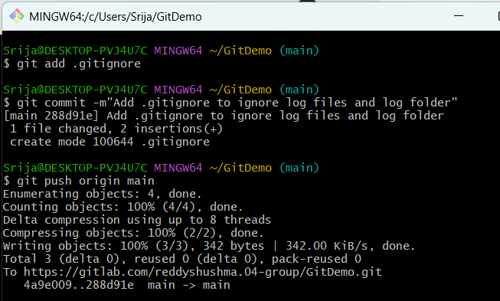

**OUTPUT:**

